**Zoo NFT game**

**https://docs.google.com/document/d/1GpqHdqxN-M-Yp3T4edcLmZQtUyv_yGf5v_WPZSy07aw/edit**

ZooGame is a decentralized game where users can play a game that will help animals, and lets you win NFTs.

Won NFTs are collected, exchanged, bought and sold.

Each user in the game will have their own virtual zoo where they can show off their collection of NFTs.

The revenue from NFT marketplace royalties will be used for restoration and maintenance of zoos and animals in wildlife.

In addition, collectors of the rarest NFTs can win special tickets for free visits to zoos, aquariums and dolphinariums. This will require the consent of the respective zoos.

Users will be able to support the zoos with donations. Information about these donations will be recorded in the blockchain and users will receive a special NFT for this, which they can display in their virtual zoo.

You get points by winning games. Every hour if you have points, you receive a token. There is a pool where tokens are held. More points mean more tokens you get. Token being distributed proportionally to points

There are 0-10 Levels in game

In order to pass the level you have to win 3 times current level

Your points will be available for 24hours.

For example, if you won 100 points, in 24 hours your points will disappear.

|  |  |  |
| --- | --- | --- |
| Level | Point for win | Game duration |
| 0 | 100 | 130 |
| 1 | 120 | 120 |
| 2 | 140 | 110 |
| 3 | 160 | 100 |
| 4 | 180 | 90 |
| 5 | 200 | 80 |
| 6 | 220 | 70 |
| 7 | 240 | 60 |
| 8 | 260 | 50 |
| 9 | 280 | 40 |
| 10 | 300 | 30 |

Token distribution each hour (halving):

|  |  |
| --- | --- |
| Number of minted tokens | Token distribution every hour |
| 0 - 2 500 000 | 16 000 |
| 2 500 001 - 5 000 000 | 8 000 |
| 5 000 001 - 10 000 000 | 4 000 |
| 10 000 001 - 20 000 000 | 2 000 |
| 20 000 001 - 40 000 000 | 1 000 |
| 40 000 000+ | 500 |

With tokens you can buy NFTs. And you can stake your NFTs in your virtual zoo.  Once you stake them you will get permanent points.Meaning those points will not disappear after 24h. Meaning you will get passive income. By holding NFTs you get points, and for points you get token every hour

|  |  |  |
| --- | --- | --- |
| NFT rarity | Point given | Price of NFT |
| Common | 100 | 100 |
| Uncommon | 200 | 200 |
| Rare | 300 | 300 |
| Epic | 400 | 400 |
| Legendary | 500 | 500 |
| Mythical | 600 | 600 |

**Future plans:**

NFT craft (breeding) - combine 2 common NFTs, pay some token and you will get uncommon NFT;

Lottery functionality with our token - twice a week. You just need to hold/stake $ZOC (zooCoin) token in order to be eligible for lottery (lottery rewards are token and tickets for zoo)

Token staking pool - combined staking between stakeholders in order to gain more rewards

NFT battle game - turn based game where characters will battle and winners will get rewards

Add more games - tetris, tic-tac-toe, sudoku, chess

Exclusive Zookeeper NFT - for most donated users

**Tokenomics**

supply : 500 000 000 ZOC

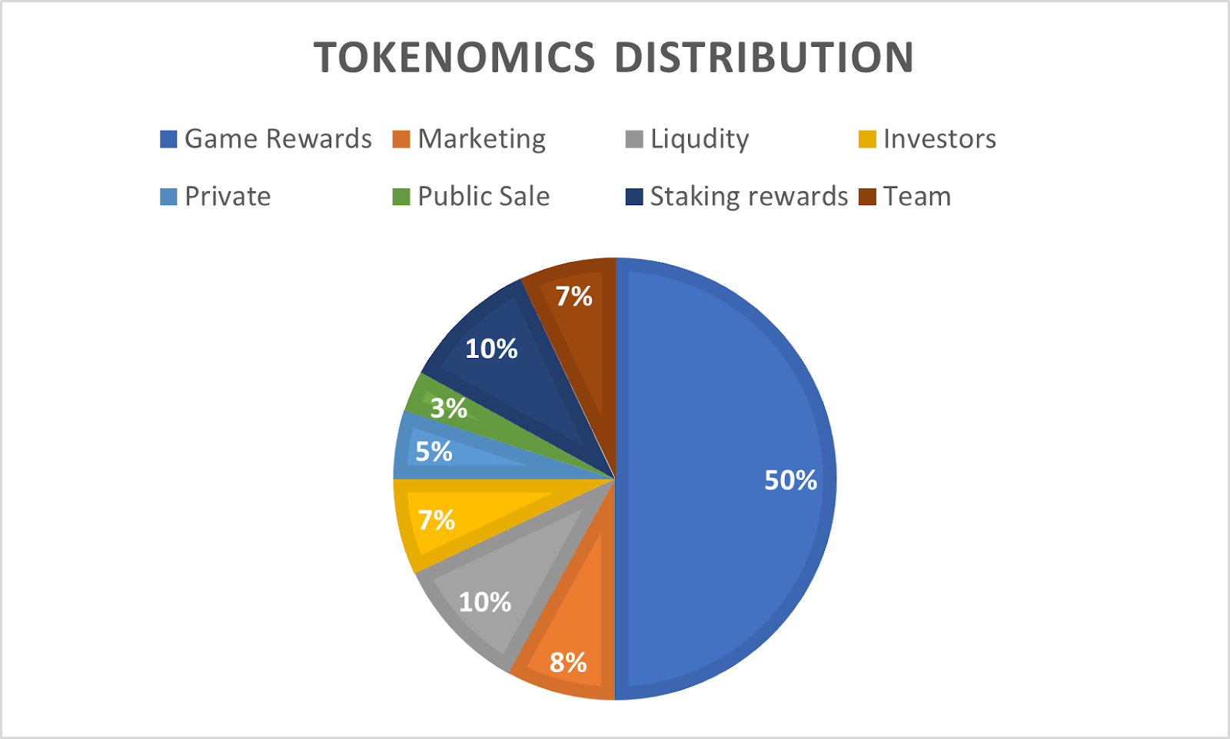

**Roadmap**

**2022 Q2**

* 

Landing Page

* 

ZOC token

* 

MVP version of game

* 

NFT Marketplace

* 

More NFTs

**2022 Q3**

* 

Private Sale

* 

Public Sale

* 

NFT staking

* 

Token Staking

* 

Lottery

* 

Add more games (tetris, tic-tac-toe, sudoku, chess etc)

**2022 Q4**

* 

NFT Crafting

* 

Breeding

* 

NFT battle game